

**“ELECTRIC VEHICLE CHARGING MANAGEMENT – DRIVER RECOMMENDATION SYSTEM”**

**SHAIK SHAHANAZ**

**A Major Project Report Submitted in Partial Fulfilment for the Award of Master of Engineering (Electronics)**

**2020-2021**

# DECLARATION

I, Shaik Shahanaz, enrollment no: N0905255, hereby declare that this project work entitled “ELECTRIC VEHICLE CHARGING MANAGEMENT – DRIVER RECOMMENDATION SYSTEM**”** is submitted in partial fulfilment of the requirements of the award of Masters of Engineering represents my own and original work and that, to best of my knowledge and belief, except where otherwise reference or acknowledge in the text.

I further declare that this report work is based on the information collected by me and has not been submitted to any other university or academic body.

# ABSTRACT

The Electric Vehicles (EV) are encounters a surge popularity and are estimated to propel a large part of vehicles on road soon. Though EV proves to be having of many advantages in all aspects when compared to conventional vehicles, still barriers arise in adopting EV due to limited power source of battery, long charge waiting time, locating Charging Station (CS).

In this research project, the proposed EV charging recommendation system to driver is based on knowing the status of the battery charge by implementing the battery monitoring system to ahead to most suitable CS to driver to recharge the battery and proposed concept of reliable communication between CS and driver of EV. This research project also proposes the implementation of the navigation system which helps driver of EV to plan, navigate to CS and destination and track the location of the vehicle.

This report works on implementation of a prototype as a battery monitoring system which determines the information of battery such as capacity of the battery, discharging current, voltage level of the battery, estimated time of charge and also alerts the driver from overcharging of battery to safeguard the battery. This system sends the alerts to driver at low charge level to locate the CS for charging the battery by using the implemented navigation system. So, acts as EV driver’s recommender system to charge and locate the CS at battery discharging to low voltage level. The test results show the battery charge related information and way for establishment of the navigation system majorly to find the charging station can be used for other navigations from the geo-location of the EV in Google maps.

# Contents

**DECLARATION** 2

**ABSTRACT** 3

**Contents** 4

LIST OF TABULAR COLUMNS 7

LIST OF BLOCK DIAGRAMS 8

LIST OF FLOWCHARTS 9

Chapter 1: INTRODUCTION 10

1.1. Context 10

1.2. EXISTING EV RECOMMENDATION SYSTEM 12

1.3. AIM and OBJECTIVES 12

AIM: 13

OBJECTIVES: 13

1.4. THESIS OVERVIEW 13

Chapter2: LITERATURE REVIEW 15

2.1. A DECENTRALIZED DEADLINE-DRIVEN ELECTRIC: VEHICLE CHARGING RECOMMENDATION 16

2.2. A REAL-TIME ANDROID-BASED MONITORING SYSTEM FOR THE POWER LITHIUM-ION BATTERY USED ON EVS 17

2.3. SIMULATION OF ELECTRIC VEHICLE DRIVER BEHAVIOUR IN ROAD TRANSPORT AND ELECTRIC POWER NETWORKS 18

2.4. RECOMMENDER SYSTEM FOR DRIVERS OF ELECTRIC VEHICLES: 19

2.5. A COST-EFFICIENT COMMUNICATION FRAMEWORK FOR BATTERY- SWITCH-BASED ELECTRIC VEHICLE CHARGING 20

Chapter 3: PROJECT METHODOLOGY AND PROJECT PLANNING 23

3.1. PROJECT METHODOLOGY 23

A. METHODOLGY OF BATTERY MONITORING AND DRIVER RECOMMENDATION SYSTEM 23

B. METHODOLOGY OF COMMUNICATION ANALYSIS BETWEEN EV DRIVER AND CS 24

3.2. PROJECT PLAN 25

3.3. PROFESSIONAL, LEGAL, ETHICAL, SOCIAL ISSUES 25

Chapter 4: PROJECT DESIGN 27

4.1. BLOCK DIAGRAM 27

4.2. DESCRIPTION OF COMPONENTS REQUIRED 28

4.3. WORKFLOW DESCRIPTION OF COMPONENETS 34

Chapter 5: PROJECT IMPLEMENTATION 35

5.1. HARDWARE IMPLEMENTATION 35

5.1.1. CIRCUIT CONNECTION OF BATTERY MONITORING SYSTEM 35

5.1.2. IMPLEMENTED CIRCUIT CONNECTION OF EV BATTERY MONITORING SYSTEM 37

5.1.3. CIRCUIT CONNECTION OF EV NAVIGATION SYSTEM TO LOCATE THE NEAREST CS BASED ON THE ALERTS FROM BATTERY MONITOING SYSTEM 39

5.1.3. IMPLEMENTED CIRCUIT CONNECTION 41

5.2. SOFTWARE IMPLEMENTATION 41

5.2.1. BATTERY MONITORING ALGORITHM 42

5.2.2. INTEGRATING THE WIFI MODULE AND GPS MODULE 46

Chapter 6: EXPERIMENTAL RESULT 48

6.1. BATTERY MONITORING SYSTEM 48

6.2. EV NAVIGATION SYSTEM: 51

6.3. DISSCUSSIONS 54

Chapter 7: CONCLUSION, FUTURE WORK AND LIMITATIONS 55

ACKNOWLEDGEMENTS 56

REFERENCES 57

LIST OF FIGURES

Figure 1 MEC-based signalling process for battery management 16

Figure 2 Android Based EV Tracking System 17

Figure 3 Architecture Model of EV Agent 18

Figure 4 SiREV main modules 19

Figure 5 EV Accessing CS Based on The Information by CS at The RSU 20

Figure 6 Methodology of Work Process of EV Management by Battery Swapping 21

Figure 7 Project Gantt report 25

Figure 8 Voltage Sensor 28

Figure 9 Arduino Uno 29

Figure 10 Lithium- polymer Battery 29

Figure 11 ESP-01S WIFI Module 30

Figure 12 GPS Module with Ceramic antenna 31

Figure 13 Breadboard 32

Figure 14 LEDS 32

Figure 15 Piezo Electric Buzzer 33

Figure 16 Voltage divider circuit of voltage sensor 36

Figure 17 Schematic Diagram showing circuit connection of Battery monitoring system 37

Figure 18 Implemented circuit Connection of Battery monitoring system 38

Figure 19 Implemented battery monitoring system in Tinkercad 38

Figure 20 Implemented Circuit for EV Navigation 41

Figure 21 Showing Part of Arduino IDE code for Battery monitoring system 45

Figure 22 Battery at Low Phase Indicating with Red LED 48

Figure 23 Half Discharge Phase of Battery Indicating with Yellow LED 49

Figure 24 Safe charged Phase of Battery Indicating with Green LED 50

Figure 25 Overcharging Alert Phase of Battery indicating with Blue LED 50

Figure 26 Serial Monitor Data of Battery Monitoring system 51

Figure 27 Serial Monitor Data Showing the Established WIFI and GPS connection 52

Figure 28 Serial Monitor Data Showing the Access of Data Through Webpage 52

Figure 29 Login Page of Local Server through IP address 53

Figure 30 Webpage showing the coordinates of the EV 53

# LIST OF TABULAR COLUMNS

Table 1 Comparison of Research Work 22

Table 2 Specification of Li-Po Battery 30

Table 3 Pin Description of Voltage Sensor 36

Table 4 Pin description of ESP-01 40

Table 5 Pin description of GPS module 41

Table 6 AT commands of WIFI module 46

# LIST OF BLOCK DIAGRAMS

Block Diagram 1 Showing Communication Analysis Between EV driver and CS 24

Block Diagram 2 Battery Management System and Navigation System 27

Block Diagram 3 block diagram showing connection of components to Arduino uno 39

# LIST OF FLOWCHARTS

Flowchart 1 Flowchart of Workflow of Components 34

Flowchart 2 Procedure to Program the Battery Monitoring System 44

# Chapter 1: INTRODUCTION

## Context

Electric vehicles (EV) are proven to be the effective alternative for the conventional vehicles. Conventional vehicles use the non- renewable energy source of fuel which has been available in limited quantity on earth and has adverse effect to environment. Owing to the eco- friendly nature to the environment the rise in the popularity to own the Electric Vehicles are being increasing. As per (Schmidt, 2019) Electric vehicles have more reasons for considering the Electric Vehicles, such as low maintenance cost, implementation of the high technology features, non- emission of gas, environmentally friendly and many more services which appeals most when compared to other conventional vehicles.

Electric vehicles relay on the electric power from the batteries. To reduce the dependency on the fossil- fuels for transportation purpose certain required regulations have been implemented by countries all over the world, and to encourage people to make use of EV for transportation subsidy schemes are introduced. Having many advantages still people are considering conventional car due to certain limitations of EV’s. As per (new.engineering.com, n.d.), (Staff, 2010), Electric Vehicles are driven by lithium- ion batteries many advantages when compared to lead acid batteries such as Li-ion batteries provides better life span cycle, Nominal voltage, specific energy, charging efficiency, light weight, low maintenance as well as safe to use. In comparison with conventional vehicle drivers the EV drivers are facing certain challenges with the limited capacity of battery and charging infrastructure and in some situations increases the range anxiety to drivers with the limited capacity of battery and charging infrastructure.

The barriers for the successful adoption of the EV are cost of the vehicle, range anxiety, limited battery capacity which offers limited travel range as per battery charge range and limited infrastructure. among these batteries of EV and infrastructure are the highlighted one. In most of the cases like as per (EVreporter, n.d.) the driver is unaware of the battery health status and due this while charging or while usage of the vehicle will be to at greater depletion rate which leads to shorten the life of battery and efficiency. This problem arises when the battery is depleted or charged to greater extent.

The EV recommendation system to the driver provides a reliable information for the management of the battery charging by locating the suitable Charging Station (CS) based on the charge status of the battery. The EV recommender system to driver shows the solution to these barriers to greater extent which were discussed previously.

Obtaining the reliable communication to driver is quiet challenging. Installation of sensors, monitoring system in combination with other detecting devices is the basic way of knowing the status of charge during trip and helps locating and providing the reliable communication to CS. In most of the EV these features have been employed as value added services which incorporates to extra cost to the buyers of EV as these applications uses the user’s information as unique identification to register and facilitates the services like pre- booking of the slot for charging to minimize waiting time at CS.

This research project proposed EV driver recommendation system which relays on the information of the status of battery to select, navigate, track and locate the vehicle to the CS while taking account of certain parameters into considerations. The proposed work mainly focuses on two concepts the internal system of the EV which monitors the battery and communication with the CS. This internal battery management system is agentless, simple and cost effective. In this battery monitoring system detects the state of charge SoC of the battery and updates the users via indicator in the vehicle. This helps the driver in the maintaining the health of the battery. The charging battery more than 80% can also affects the battery life span cycle and reduces the efficiency of the battery. the driver gets the alert from the battery monitoring micro-controller device depends on the capacity of the battery. When the battery capacity is below threshold level it alerts the driver through indicator and buzzer and provides option to select the best suitable CS nearest to the EV. With the advancement of Internet of Things (IoT) the notification and communication system can be done easily between monitoring system and driver of EV. This project report also proposes the concept of the effective communication channel between the EV driver and CS and allows the driver opting to pre-booking of slots and gets the information of the type of charge available thus the charge wait time can be reduces and drive can pre analyses the situation and acts accordingly.This research project describes about the battery monitoring, battery charge management system and infrastructure of CS for EV to meet maximum possibility requirement in terms of EV driver in locating CS and consuming less time for charging their EV with proper management and GUI interface for easy access to driver for resolving upcoming the problem. The recommendation system for EV driver is maintained by cloud server or web server which access the data by GPS data of the vehicle and sends the locations of nearest CS to the EV in maps.

The focus area of this research project is to provide the recommendation to the driver in larger area with following summary of contributions

* A real- time recommendation system to driver based on the parameters of the available juice.
* Avoiding the battery damage by Pre- alert system to EV’s driver before battery being fully depleted battery.
* Locating the nearest CS’s and suggesting the best among them with the data from the server such route, availability of slots, charging time, charging waiting time, availability of plug-in connectors.
* Reservation facility of slots at CS to avoid the waiting time by providing the booking facility by selecting the available time slot.
* At an emergency condition, battery swapping facility at CS by pre-booking the battery providing the registration number of EV which gives the detail of EV model, year of manufacture, capacity of battery and battery parameters.
* Improving the charging infrastructure at the crowed CS and the area of non-availability of CS at certain range of distance.
* Cloud based EV charging management system for the optimised selection of the CS and reservation.

## EXISTING EV RECOMMENDATION SYSTEM

This section studies about some of the private organisation which provides EV charge management systems services to their registered users, by providing them the real time assistance to locate the CS, payment options, user charge behavioural patterns.

EV connect sourced from (EV Connect, n.d.) is a CA USA based website with a support of Driver charging App which is used to easy locating, navigating and utilizing the selected CS with provided ID while registering to the website. This is acts as third-party service provider between EV driver and CS, where it provides the details of CS to EV driver, its payment option and methods, charging time, waiting time and maintains the user’s database of previously charging sessions however it lags in the feature of EV battery management.

Driivz solutions, as per (Driivz, n.d.) is a cloud-based software platform provides the software solution for the management of EV charging operations, charging stations network and driver self- service tools. This is an online EV service provider for monitoring EV charging network and energy management solution, but this paid serviced tool and EV needs to be connected to this system to access these services.

From studying the above implemented EV charge management service provider system provides the basic information for further research work to be carried out for the implementation of CS recommendation system for EV drivers.

## AIM and OBJECTIVES

The aims and objective of this research project is specified, the aim specifies the overall vision of the project and the objectives the critical approaches to requires achieving the aim.

### AIM:

The aim of this research project to propose an EV driver CS recommendation and navigation system based on agentless EV battery monitoring management system.

### OBJECTIVES:

The aim of the proposed research project can be achieved by following objectives.

* To get the status of the battery charge capacity.
* To build the battery monitoring system.
* To provide the agentless EV navigation system.
* To provide the time to driver to plan the trip accordingly by knowing the battery capacity and location of CS in google maps.
* To select the nearest CS from google maps from the driver location as google maps shows the navigation by considering the parameters like distance, time of journey, traffic etc.
* Able to track the vehicle by connecting to the local severs webpage through any device.
* To construct a compact and cost-efficient device which can be easily connected to existing system without much modification.
* To further suggests the ideology of Establishment of secured cloud-based server for required for the communication between driver and CS for selecting the appropriate charging slot with all details among available options required based on model of EV.
* Providing the required charging plug- in connectors and type of charge according to model of EV at CS based on the registration number of the EV for selecting the CS.

## THESIS OVERVIEW

The project report on “Electric Vehicle Charging Management and Driver Recommendation System” has been divided into seven chapters, which are formulated as follows:

Chapter- 1: Introduction; A general description of the development of the EV recommendation system to driver by providing solutions to the present state of related issues and development approach by identifying the similar existing product. The aim and objectives of this project is described which represents contribution of the research project work.

Chapter-2 Literature Review; This chapter provides the relevant information of previous works which are performed at different areas are considered for the formulation of this research project report.

Chapter-3 Project Methodology; This section of the research project explains about the steps taken to begin with the collection of primary data which were used to develop the Battery monitoring system, which sends the recommendations to driver to charge at certain voltage level and a way to establish communication system between the CS and driver of EV. This section further continues with detail description of the project plan and relates issues with the development of the project report.

Chapter-4 Project Design; This chapter deals with general view of the proposed systems and technically focused to achieve the proposed design by defining working of each components with technical details, it also explains about the workflow integration of the all the components which are required to achieve the objectives of the proposed project.

Chapter-5 Project Implementation; This chapter deals with the hardware and software implementation of the prototype by explaining about the circuit connections and development of steps required for coding as part of the software implementation for both battery monitoring and EV navigation system.

Chapter-6 Experimental Results; The section shows the output of the implemented battery monitoring system and navigation system at different phases. This section also discussed about the results and suggested the approach of modifications to this implemented project report.

Chapter-7 Conclusion, Future Work and Limitations; this section gives the brief outline of the implementation of this research project and concluded with achievement of the aim and objectives. This section further deals with the limitations of implemented project report and future plans where this research project could be taken further to overcome the limitations.

# Chapter2: LITERATURE REVIEW

The rise of the popularity of Electric Vehicles [EV] are increasing at faster rate and due to this gain popularity and its varied applications manufactures of EV are releasing the versions of Electric Vehicles [EV] in the market. The world is now concerning about the greener and cleaner environment. Combustion of fossil fuels is the major cause of the air pollution (based on the article*(Madaan, 2016),* progressive methods are been implemented to reduce the harmful effects of the global warming and greenhouse gas emission all over the world. So, the world is shifting towards the renewable energy and in this regard the demand of the Electric Vehicles [EV] is increasing. The growing demand of EV’s are because of the various benefits when compared to the conventional vehicles like it has low maintenance cost, reduces the pollution, environmentally friendly as major parts are made up of recycled materials and great driving experience. However, with great benefits of EV’s there are certain challenges regarding to the Charging of the EV at charging station during long trip journey due to limited battery capacity of electricity. This leads to the grab attention for the availability on public Charging stations (CS). This literature review mainly focus on the constrains which are arises for the EV driver related to the charging of the EV on different aspects such as during long journey, searching of CS, availability of slots for reservation at CS before reaching by automatically searching by the in-built car and mobile based cloud *(Cao et al., 2018)* applications so that the driver can make a smart move based on the cloud data in selecting among the nearest CS and type of charging facility.

Charging Stations management is being widely adopted by majority of previous research works by (Cao et al., 2018), (Egbue and Long, 2012),  (Cao et al., 2019), (Cao et al., 2018) and  (Cao et al., 2019) which are focused on the optimal recommendation method for the electric vehicle driver that specifies the selection of charging station to charge the vehicle by monitoring the local status of the CS as per the report study by (Cao, Y., Kaiwartya, O., Zhuang, Y., Ahmad, N., Sun, Y. and Lloret, J. (2019)) and (Cao et al., 2018)) and chance to reserve the slot in advance for only particular time slot which reduces the waiting time. Some related work  (uk.nec.com, n.d.) also specified the battery switching techniques so that driver can swap the depleted batteries with the fully charged batteries which considerably decreases the waiting time and charging time. further research study also focused on the need of the development of the potential issue that it will include the interfacing of the grid side communication so establish counterfeit communication by which the hackers will establish between the vehicle and charging station and which results in the alteration and manipulation with the battery management system of the EV. So, at present there are few charging stations are available but due to the increase of the number of EV users at the CS, leads the discomfort to the drivers to wait for long time at charging station to get the turn to charge the vehicle and vehicle charging time.

Literature review of the project is based on previous related work that has been carried out in addressing the concerns related to the EV driver recommendation of the system in this project. The related work of this project work is categorized into two parts. The first part deals with the EV charging recommendation to driver by monitoring the battery with the use of IoT technology for alerting and locating the CS and in the second part deals with the communication between the EV driver and CS. Battery management system on EV is the main factor to be consider, as it is the main component on which every function of the Electric Vehicle are done. Battery managements system deals with the protection of battery from overcharging and over- discharging, heat and charging recommendation. These factors increase the life span of battery.

## 2.1. A Decentralized Deadline-Driven Electric: Vehicle Charging Recommendation

This this research works by the author ‌Cao, Y., Kaiwartya, O., Zhuang, Y., Ahmad, N., Sun, Y. and Lloret, J. (2019)) has proposed the concept of EV charging management in terms of four phases. The phases are as Driving Phase, Charging Planning Phase, Schedule Charging Phase and Battery charging phases. The author ‌Cao, Y., Kaiwartya, O., Zhuang, Y., Ahmad, N., Sun, Y. and Lloret, J. (2019) p[proposed the theory for the reliable communication of the EV driver and Charging station achieved by cloud based computing that is Mobile edge Computing MEC. In this describes the charging infrastructure build and management ways to reduce the supply demand gap. Here the driver sends request to global controller (GC) through cellular network where GC continuously monitors the status of the charging station CS and provides the best possible option to the EV driver for the booking of the reservation of slot. The proposed theory work is defined through the following example figure.

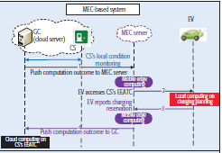

Figure 1MEC-based signalling process for battery management

The main features of this proposed report by the author are

* It provides the best available CS option to charge.
* CS are continuously monitored by GC, a cloud-based controller to provide the on-demand information to the EV driver.
* MEC provides access from EEATC so that at below the threshold level of battery it provides the option for recommendation of charge at CS.

The author [5] in this proposed system in which the EV charging management is carried out four phases, which are driving phase, charging planning phase, charge schedule phase and battery charging phase. The mobile edge computing MEC server enables the access control, aggregation while EV charging recommendation takes place which will benefit the driver of EV in charge wait time, but this system doesn’t give insight of battery management system. The proposed MEC based signalling for battery management had explained the detailed about the recommendation system and focused on communication system done between the driver and charging station but this is an agent based system and only work done on the supply demand gap reduction but there is no internal battery management system and sometimes the driver is unaware of the charge options and connectors to select the required charging slots or CS.

## 2.2. A Real-Time Android-Based Monitoring System for The Power Lithium-Ion Battery Used On EVS

The author (Menghua and Bing, 2017) proposed a concept of on- board lithium– ion batteries with real time monitoring system using W-Fi module. With WIFI communication the driver of EV can gets position coordinates of the EV on android based smartphone. The salient features of proposed concept are that it determines the name of the place and position of EV in Google Maps but lags in the determination of battery charge status through data analysis on the cloud server and recommendation and navigation to Charging station-based on battery charge status.

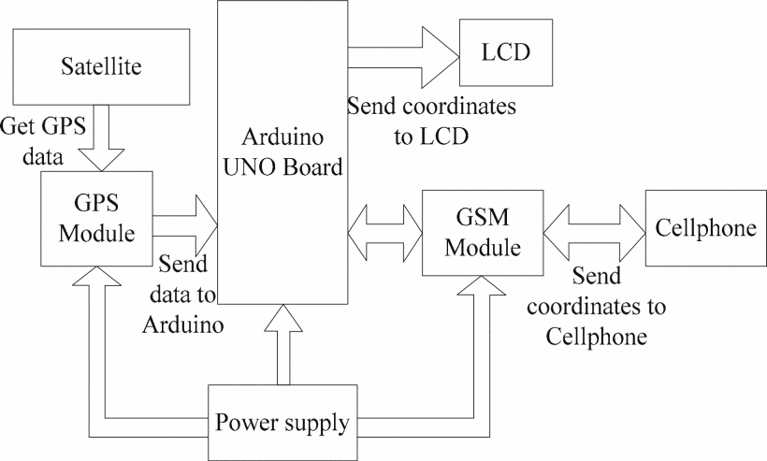

Figure 2 Android Based EV Tracking System

## 2.3. Simulation of Electric Vehicle Driver Behaviour In Road Transport And Electric Power Networks

In this research work the author (Marmaras, Xydas and Cipcigan, 2017) has proposed the approach which is based on the integrate simulation between the road transport and electric power system to learn the behaviour of the EV driver on the daily basis for the recommendation of the CS and in home to improve the magnitude of impact which affects the electricity grid and develops the framework by which the interactions that stored the data based on the usage of the public charging station, price of electricity and the demand gap, waiting at charging stations to develop the infrastructure by the concept of EV Agent.

In this model the EV agent must focus on the following task that it has to find the route to destination i.e., implementation of navigation system and When the battery juice is below SoC the recharging of the battery.

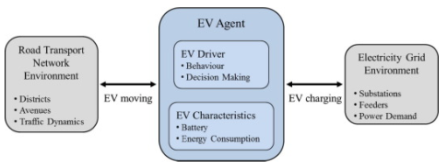

Figure 3 Architecture Model of EV Agent

The features of this proposed simulation are listed below

* Analysis of the behaviour of the EV driver is useful for decision making and pre allotment of slots recommendation is provided.
* Battery health status is can be calculated based on the distance travelled with the last charge data.
* The information of the feeders is provided to ensure the safety level of charge at home or at on street point.

However it seems that in his the author (Marmaras, Xydas and Cipcigan, 2017) not able to work on the real time data from geographical location and larger area and finds the limitation in the unaware EV agents which is having limited initial data and it would be a strength if there an battery monitoring system.

## 2.4. RECOMMENDER SYSTEM FOR DRIVERS OF ELECTRIC VEHICLES:

By this report work the author (Ferreira, Pereira and Filipe, n.d.) proposed a recommender system called SiREV for EV which provides the right information to the EV driver through GUI devices. This proposed system integrates with the diverse functioned modules. These modules are

* GPS module: the SiREV able to locate the current position of the EV and calculates the distance between the EV and destination.
* Public transport Information Module: this module is serves as additional feature to the EV drives which gives the option to the driver the route path and near location of the public transport which is availed to use or not depends on the choice of the EV driver.
* Energy market Information module: in this module EV driver can set the cost value to which the recommender system can use at the charging station is the value reaches above the defined euro/ KWh the recommender system automatically stops the charging of battery.
* V2G, Vehicle to Grid module: here it collects the information for the status of the battery charging and update the information at regular period of interval of time to control the range of the vehicle battery.
* Module for the reservation of slots at CS: here the recommender system suggests the CS to book the slot while on board depends on the capacity of the remaining charge of the battery.

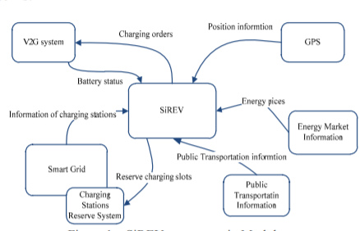

Figure 4 SiREV main modules

Strengths of this proposed research project are

* SiREV is a recommender system which provides its operation as a recommendation to the driver of EV into different modules which is helps the driver of the for making smart decision.
* It provides the information of the grid for booking the slots for charging depends on the battery status.

The author has explained the almost all the possibilities through his proposed work but practical implementation of this project is highly complex though the system proposed by author shown the general concepts of the feature to be includes but the reliable communication system is having to explain with proper scenarios which is the basic operation to be implemented foe the recommender system. (Ferreira, Pereira and Filipe, n.d.) author proposed SiREV recommender system to driver of EV through different modules for making smart decision, however this is the proposed study of the author achieving the real implementation is quiet challenging and this proposed recommender system uses number of third party agent for communication the vehicle to grid based on the status battery and reserving slots which makes the system to be complicated to achieve. For the reliable communication between the EV and CS with respect to the battery monitoring

## 2.5. A COST-EFFICIENT COMMUNICATION FRAMEWORK FOR BATTERY- SWITCH-BASED ELECTRIC VEHICLE CHARGING

In this article the author (Cao et al., 2017) proposed the research work based on the battery switch swapping with cost efficient methods. By this method the EV driver can avoid the long waiting at CS for battery recharge.

Here each charging station is locally connected with number of roadside units RSU. When the EV battery gets depletes (Cao et al., 2018) and is the range of one of the RSU then EV subscribed the information relayed to its RSU and sends the status of the battery SOC. The EV then starts the selection of CS for the battery switch. Here RSU act as the mediator between the CS and EV.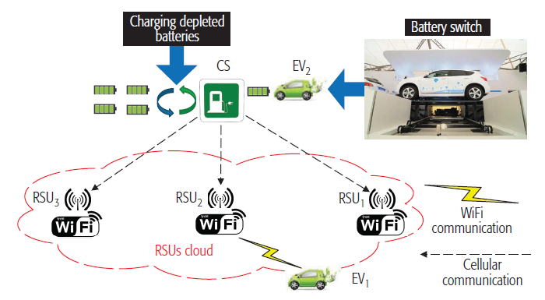

Figure 5 EV Accessing CS Based on The Information by CS at the RSU

After receiving information from the EV the charging Station provides the facility by mobile service the fully charged batteries to swap.

Communication framework between the CS and EV by the following system cycle required for the battery switching.

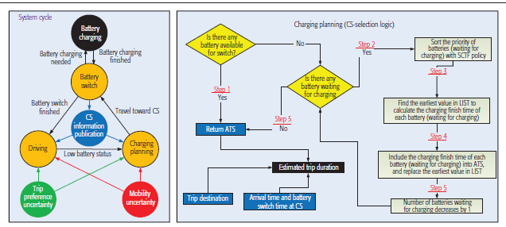

Figure 6 Methodology of Work Process of EV Management by Battery Swapping

Strengths of the proposed framework are

* Reduce waiting time at CS needed while battery charging.
* On the move EV charging by which the process of charging can be improved by implementing this proposed work.
* Real time low battery alert system and charge planning with CS selection.

There are certain considerations to be taken into notice such as, CS must maintain each type of batteries based on the demand of EV by ensuring the battery is of full charge, so the depletion rate of batteries increases, and these batteries must be sold to the grid and there many be chances of security breaches and false information of CS and its batteries.

Table 1 Comparison of Research Work

|  |  |  |  |  |
| --- | --- | --- | --- | --- |
| EV Recommendation Systems | Strengths | Weakness | Solution | Implementation |
| A Decentralized Deadline-Driven Electric: Vehicle Charging Recommendation | Reliable communication with the use of cloud server | No identification of the details of vehicle for providing relevant service | By implementation of the unique ID of the vehicle by which the details of vehicle required for CS for allocation charging slot | It is useful in my project to implement the overcome solution |
| Simulation of electric vehicle driver behaviour in road transport and electric power networks | Battery health status is provided.  Based on the battery status reservation recommendation is provided to EV driver  Feeder information is provided to ensure safer charging methods. | Not able to provide the real time data and geographical location | By implementing the GPS module | Feeder charge information is useful for the driver to safety purpose of EV. |
| Recommender System for Drivers of Electric Vehicles: | Added many features like live updates of the traffic,  Reservation of slot and rate of charge per unit | Recommender system has not explained how the communication system works | By implementing the architecture of the reliable communication system between CS and EV driver | this architecture with load balancing techniques helps in providing the faster and secured connection |
| A Cost-Efficient Communication Framework for Battery- Switch-Based Electric Vehicle Charging | Less waiting time to charge the battery  Useful in emergency situation | Security in communication system  High chances of the depletion of batteries | Battery management technique is needed to employ | The strength Can be implemented in the project plan |

# Chapter 3: PROJECT METHODOLOGY AND PROJECT PLANNING

## 3.1. PROJECT METHODOLOGY

This project proposes an EV diver recommender system for charging and locating Charging station as an attempt to reduce the range anxiety of EV driver and most of the barriers that are faced by EV driver or adoption of electric vehicle. By considering the above researched works this research project concept is divided into two phases of systems, where one of the system is explains about agentless charging recommendation system and battery monitoring system and CS locating and navigating system where other system depends on the communication between the selected CS and driver of EV.

### METHODOLGY OF BATTERY MONITORING AND DRIVER RECOMMENDATION SYSTEM

In this proposed project report, the battery monitoring system is considering to be the essential one for the EV. The driver of the EV gets the alert of the charge from the in-built battery monitoring system and nearest EV charging locating system. The main feature of the battery monitoring system it is agentless, cost- effective, secured as it doesn’t need to share the information to any agent. It helps the battery in monitoring the battery health status and alerts the driver at overcharging and over- discharging of the battery and increases the efficiency and life span of the battery. By this recommendation of the system driver can be estimate and pre-plan the journey regarding charring of the vehicle.

As per the overview, for the system to work, the battery voltage level measures by the voltage sensor. The GPS module with the system always locates the position of the EV on the map and the readings of the voltage sensor and the location of EV are fed to the Arduino Uno microcontroller for further processing as per the coding dumped to it. as per the voltage level the of the battery the status of the battery can be shown to the driver to the EV. in this report the status of the battery voltage level is displayed by using LED’s and buzzer when the battery voltage level reaches the threshold value and cut- off level value of voltage then by using the GPS module the location of the Charging station is shown to the user in maps. Driver from the map data can select the suitable CS depending on the parameters like traffic congestion, duration, distance by the information of the maps. The detail design of the system and working methods are described in this report.

### METHODOLOGY OF COMMUNICATION ANALYSIS BETWEEN EV DRIVER AND CS

In this project report, every EV has registered with the registration number is act as the unique ID with official transport department. Based on this registration number the model of the car, year of manufacture, battery model, battery capacity and type of charge suitable for this model, model of plug- in based connector and also specifies whether it is suitable for fast charge and many more related data are obtained. This information is stored in the centralized cloud sever for Electric vehicle charging by registering to it.

Charging station

Driver/user of EV

(CENTRALISED) EVC CLOUD SERVER



LOCAL AREA EVC CLOUD SERVER

Block Diagram 1 Showing Communication Analysis Between EV driver and CS

EV is connected to the cloud server by Wi-Fi and Charging stations are connects with the cloud servers by cellular based internet. This project mentions the implementation of two different types of cloud server, one which governs all the operations by allocation the sub operations to other sub cloud server. This sub server allocates at each area, for load balancing and minimizing the complexity of the network communication and easy maintenance.

When the EV needs charge then EV sends request, the request reached to the centralized cloud server for EVC. The cloud EVC server finds the location of the EV by using GPS and allocates the information of EV to local area cloud server for EVC which continuously monitors the status of the CS and it selects the CS based on the direction of the journey of EV, CS selection is in terms of nearest distance of CS in ascending order of distance and also selects the requires CS by the Rn of EV and sends the information of CS to further selection and booking confirmation of the CS.

This methodology is one of the ideological way to approach CS, it is needed only when driver pre plan the trip by booking the charging slots to reduce or avoid the waiting time at CS to charge the vehicle or at certain emergency situation where it is needed to get the immediate services from the nearest CS.

## 3.2. PROJECT PLAN

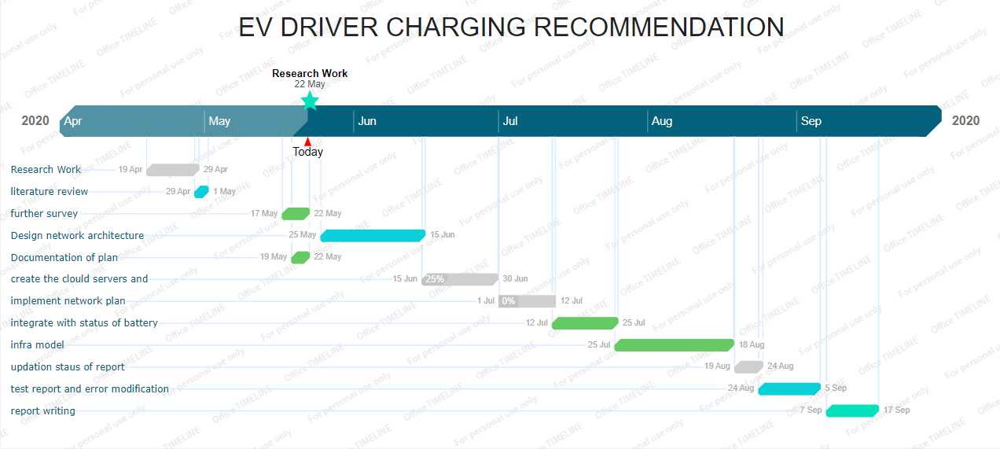

Figure 7 Project Gantt report

## 3.3. PROFESSIONAL, LEGAL, ETHICAL, SOCIAL ISSUES

1. PROFESSIONAL ISSUES:

The construction of entire process for project operation is to enhance the efficiency by opting the standardized management with proper documentation and by providing information of all relevant sources used.

1. LEGAL ISSUES:

The information needed for considering the operations of the project should be used based on the detailed agreement of government and private bodies to ensure the secure data and avoiding misreading of data such as data theft, data manipulation.

1. ETHICAL ISSUES:

Agreement is made to ensure not to affect norms, values and thoughts of an individual.

1. SOCIAL ISSUES:

Changing in the price of electricity will affect the price of charge at charging station which will affects both the individual public and private organization. So, there will be effective coordination and operation between both public sectors that is government sectors and private sectors to ensure the success of project.

# Chapter 4: PROJECT DESIGN

The battery of EV is the ultimate source of the all the operations of the vehicle and the proper maintenance of the battery is must be taken for smooth uninterrupted operation of the vehicle and comfort of the driver. In this proposed implementation of the EV driver recommendation for charging the battery and locating the CS based on the status of the battery so it requires microcontroller battery charge monitoring system. Here for the designing and attempting the proposed recommender system as stated above is Arduino based agentless EV’s driver Charging system by fulfilling all the mentioned objectives of the report.

## 4.1. BLOCK DIAGRAM

Depending on the technical functionality of the recommender system the components are used and arranged as shown in following Block diagram 2. Arrangements of the components are done at the location of the battery to reduce the complexity of wiring. The general view of the components of the system are represented as per the connections.

Block Diagram 2 Battery Management System and Navigation System

**EV NAVIGATION SYSTEM**

**BATTERY MANAGEMENT SYSTEM**

Satellite

Indicator system

GPS Module

Arduino Uno



Arduino Uno

Wi-Fi module

Voltage sensor

User’ device (App, web)

Battery

## 4.2. DESCRIPTION OF COMPONENTS REQUIRED

Detail description of the components required to build the recommender system for the desired functions with technical details are represented in this report.

List of components required to build the proposed system are:

1. **VOLTAGE SENSOR**

In this project voltage sensor module is used to measure the voltage level of the battery. This module uses a resistive voltage divider circuit to reduce any input voltage by factor of 5. By using this module, we can make the large voltage into smaller voltage as per the voltage suitable of the Arduino board. This module is used to protect the board from high voltage supply as input i.e., more than 5V which can damage ATmega328 IC with high voltages.

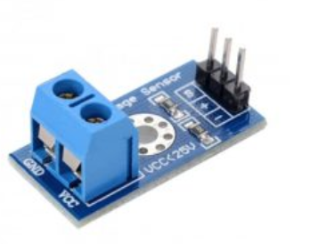

Figure 8 Voltage Sensor

Specifications:

The operating voltage of this module range is 0 to 25v

The voltage detection range is 0.02445 to 25V

Can be easily interface with the microcontrollers.

1. **ARDUINO UNO:**

The open sourceArduino uno microcontroller board based with8- bitATmega328P microcontroller is the vital component of the project. It contains the software data of the project. The battery is given as input to it and reads the analog data and as per the code it executes and operates the other components to it and send the output to the users. To program the Arduino board Arduino Integrated Development Environment (IDE) is needed. It has 14 digital input/output ports, out of these 14 ports, 6 ports are used to control PWM outputs.

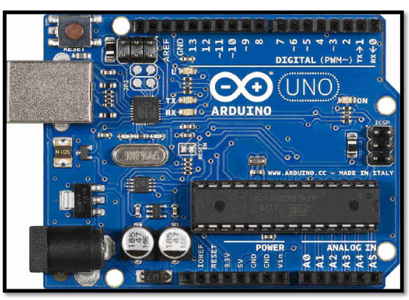

Figure 9 Arduino Uno

The battery is voltage is measured by voltage sensors and its readings are fed to Arduino Uno analog input A1. Here must cautious while connecting battery directly to Arduino board as Arduino board can damage if the voltage is beyond 5V and to safeguard the Arduino board it is requires to take precautionary steps as by using voltage divider circuit if the battery output voltage is more that 5 volts.

The Arduino has 6 analog pin inputs from A0 to A5 and are lowed to convert the analog input to discrete 10-bit digital form as the microcontroller can able to read the discrete digital values.

1. **Battery**

The battery which is considered for the demonstration of the project is rechargeable lithium polymer battery i.e., Li-Polymer battery. The specifications of the battery are given at Table 2.

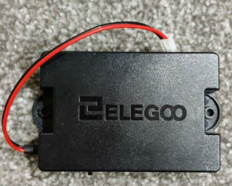

Figure 10 Lithium- polymer Battery

Table 2 Specification of Li-Po Battery

|  |  |
| --- | --- |
| **Parameter** | **values** |
| Charge voltage | 4.2V |
| Nominal voltage | 3.7V |
| Discharge cut-off voltage | 2.45V |
| Nominal capacity | 1800mAh 1C discharge |
| Discharge Current | 1.5C |

1. **ESP8266 ESP-01 Wi-Fi MODULE**

ESP-01 WIFI module when connected to Arduino board to get the ability of Wi-Fi or acts as board with Wi-Fi shield to access the Wi-Fi network. The module doesn’t gets manipulated with the code of the Arduino as ESP -01 is a self -contained system on chip (SOC) so act as mini micro-controller.

This module is used in the project to establish the communication between the Arduino system and other devices.

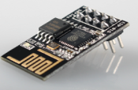

Figure 11 ESP-01S WIFI Module

ESP operates in three modes. They are-

1. Access point (AP) – to establish the communication between the module and device by Wi-Fi.
2. Station (STA)- in this mode of operation the ESP module allows the device connected to the network for communication.
3. Both – in this mode the ESP-01 can act as both Access point and Station.
4. **GPS MODULE**

For navigation and location of EV charging station and EV NEO-6M GPS module is used as shown below Figure-12. GPS module is compatible with Arduino board microcontroller. To transmit the position data via serial port all GPS module uses NMEA (National Marine Engineering Association) (vi.raptor.ebaydesc.com, n.d.) protocol, provides time-based geolocation information and are designed by u-blox to receive updates from various satellite on different channels to get the position of the receiver device.

When connected to the Arduino it displays the altitude, speed, date and time. In this project with the help of this module we can track the EV, locate and navigate through CS and destination.

In this project the GPS module continuously locates the position of the vehicle on the google maps.

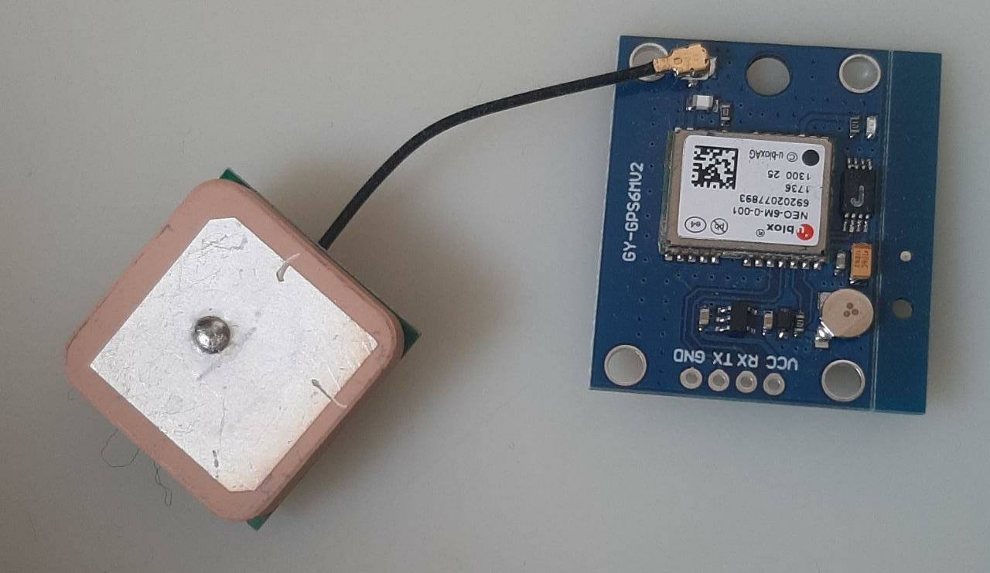

Figure 12 GPS Module with Ceramic antenna

**Features:**

* + 1. GPS module comes with ceramic antenna.
    2. It saves all the configuration of data by EEPROM.
    3. It has LED signal indicator.
    4. It works with default BAUD RATE of range 4800 to 115200BPS.
    5. On- board memory chip
    6. Rechargeable battery
    7. Operating voltage of this module is 3.3V to 5V.

1. **BREAD BOARD**

Required Connections of all the components can be constructed on to the Arduino uno can be simplified by using a small adhesive bread board to test the design as estimated and can easily modify the connections by using the breadboard.



Figure 13 Breadboard

1. **LED’S**

To know the battery status LED’s are used. Light Emitting Diode operates on the values obtained from the output voltage level of the battery and depending on these values the corresponding lights that is red, blue, yellow and green light will glow at different voltage level and are controlled by microcontroller.



Figure 14 LEDS

RED LED – Glows when the battery voltage level is low and about to discharge completely and alerts the drive to charge the battery immediately to avoid complete shutdown of the vehicle.

BLUE LED – Glows to indicate driver of EV to the battery being overcharged to avoid the damage to the battery with overcharge issues and to ensure the safe amount of the voltage level to prolong the health of the battery.

GREEN LED - Glows when the battery is having enough charge to drive on trip without being hassled to locate CS to charge and range anxiety.

Yellow LED- Glows when the battery being discharged to 50% or more and to locate the charging station and plan the trip accordingly so this gives the driver the ease in range anxiety and comfort driving.

1. **Buzzer**

The electronic buzzer is used in the project as to alert the driver through tone when at low battery voltage level so that driver will immediately responds to it and takes require action for the conservation of the battery and navigates to the nearest EV charging station

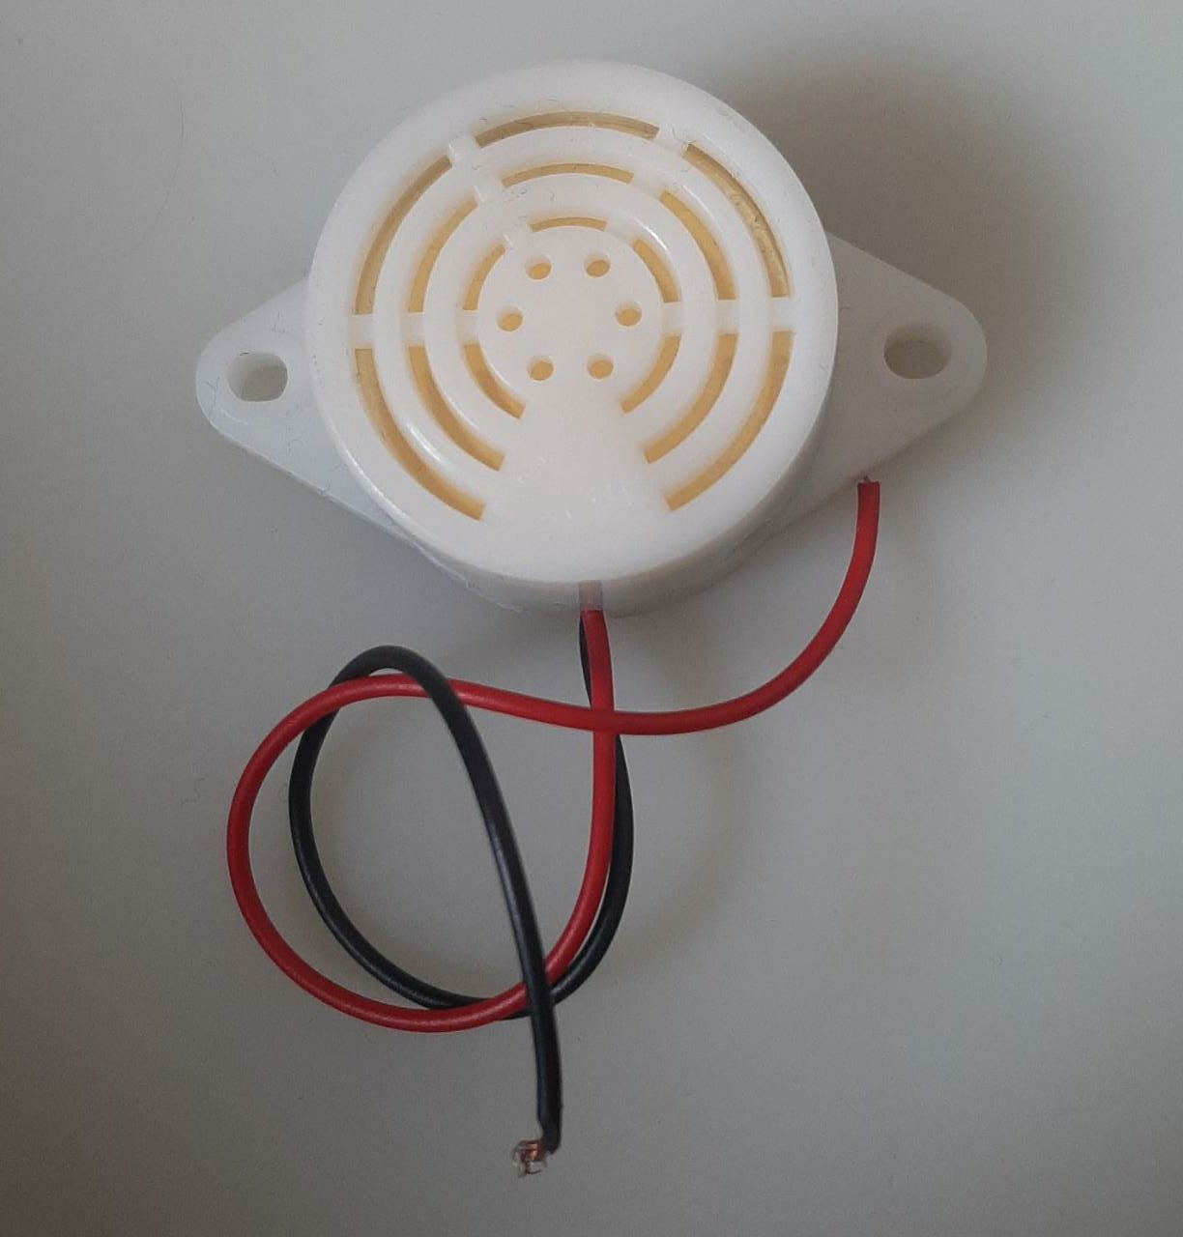

Figure 15 Piezo Electric Buzzer

Specifications:

The specifications of the product as per the manufacture (aliexpress.ru, n.d.) are

It operates at the voltage of 3 -24V

It produces a minimum of 80 dB sound output with the resonating frequency of 3100 ± 500 Hz.

The rated current and voltage of this electronic device are 20mA and 12V.

## 4.3. WORKFLOW DESCRIPTION OF COMPONENETS

The workflow process of battery management system and EV driver charging station recommendation is described by following flowchart.

Arduino reads the battery voltage level

Identify the condition of the battery with discharging current, battery capacity and voltage

No

Is V<3.7 V

Displace the condition of battery to driver of EV. Green LED will glow

yes

Displace the condition of battery to driver of EV as “Battery is discharging”. Blue LED will glow.

Is V<2.7V

Yes



Displace the condition of battery to driver of EV as “Low Battery, Locating CS”. Red LED will glow

No

Does Driver opt for charging rging



Select CS from the map data navigation

Reserve slot at CS =?

No

Connect to CS with cloud server

Check availability and book slots

Start Navigation to CS

Flowchart 1 Flowchart of Workflow of Components

# Chapter 5: PROJECT IMPLEMENTATION

The proposed project system the all the above described components are arranged at the location of the battery of the EV. The battery management system is controlled by Arduino microcontroller and it is connected with the GPS module which continuously locates the altitude and latitude of the vehicle. This battery monitoring system is connected wireless through ESP-01 module to the devices of the driver and can be monitored through the web browser.

## 5.1. HARDWARE IMPLEMENTATION

The features considered for constructing the hardware design of the battery monitor and charge recommender system are listed below:

* Driver can be able to monitor the voltage of the battery, discharging current, capacity of the battery.
* The cost-efficient build parts the system.
* Can able to communicate with the driver wirelessly.
* Can able to alert the driver with by the implementation of IoT.
* Over- charge and over-discharge alerts.
* Automatic locating of the electric vehicle Charging station and navigating to the CS as per the selection made by the driver.
* Simple and Compact in size.

### 5.1.1. CIRCUIT CONNECTION OF BATTERY MONITORING SYSTEM

For the battery monitoring system the basic components required to build are voltage sensor to which battery is connected to measure the battery voltage level and to divided the larger voltage level into suitable level as output to the microcontroller board, LED’s as indicators and Arduino uno microcontroller.

As show in circuit connection in below figure-18, the controller board is connected with the voltage of 5V which is in the suitable range of the microcontroller but when the voltage level is more than the operating level of then a voltage divider circuit is to use in conjunction with the battery to safeguard the ATmega328P IC on Arduino uno board.

Voltage sensor is used a potential divider to reduce the input voltage by factor 5 and fed to analog input of controller board and can used to measure the voltage up to 25V.

The description of the connections that are required at each terminal and operations are explained below for each component.

It consists of two resistors in series which are divides the input voltage from the battery within the range of the Arduino board and fed to the analog input of Arduino pin.

Pin description of the voltage sensor is given below:

Table 3 Pin Description of Voltage Sensor

|  |  |
| --- | --- |
| **Pin** | **Connection** |
| VCC | Positive terminal of battery of voltage range (0-25) V |
| GND | Negative terminal of battery |
| S | A1 pin of Arduino |
| + | Not connected |
| - | GND pin of Arduino |

The schematic diagram of the voltage sensors as shown in Figure-16, as per the gathered information from (Osoyoo.com, 2018), (ElectroSchematics.com, 2013) consists of two resistance of 30KΩ and 7.5KΩ, the battery is connected through the this circuit and to divide the voltage and fed to Arduino Vout is connected to the middle of the both resistors then Vin is calculated.

VCC

R1 = 30KΩ

S = Vout = Vin R2 /(R1+R2)

R2 = 7.5K Ω

GND _

Figure 16 Voltage divider circuit of voltage sensor

The voltage is fed to the analog input of the Arduino and it converts into binary as the Arduino detect the (2^10) discrete analog levels as described in  (learn.sparkfun.com, n.d.). As per calculation and code explained in next section the light indicating diodes which are act as voltage level indicators will blink. As shown in below figure-17 the voltage sensor is used in the connection by considering the supply voltage is more than 5V to reduce the voltage to safe level of the operating voltage of the Arduino Uno microcontroller board but in the implemented circuit connection the battery used is having the nominal voltage of 3.7V so there requires no further connection of voltage sensor to limit the voltage to safe level.

The Figure-17 shows the schemattic diagram of the ciruit connection of Battery Monitoring System:

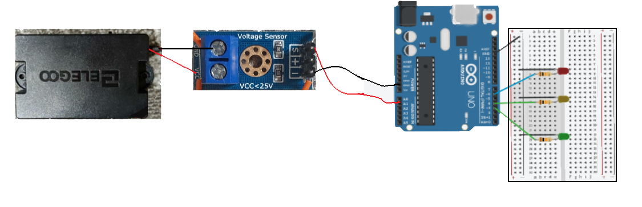

Figure 17 Schematic Diagram showing circuit connection of Battery monitoring system

### 5.1.2. IMPLEMENTED CIRCUIT CONNECTION OF EV BATTERY MONITORING SYSTEM

The implemented circuit connection of the EV battery monitoring system is represented below figure-18. As shown the battery level indication can be identified by the LED’s as described. The system is connected to the buzzer so at the low voltage levels that is before the cut-ff voltage it alerts the driver of the EV as being get discharge and to locate for the charging station immediately to recharge the battery.

According to the above schematic diagram above the voltage sensor is nor used as the battery used has normal operating voltage of 3.7V and can be charged to 4.2V so to reduce the complexity of wiring and demonstration of the working of the protype voltage sensor is not connected but has to be cautious with the voltage level while connecting to the microcontroller.

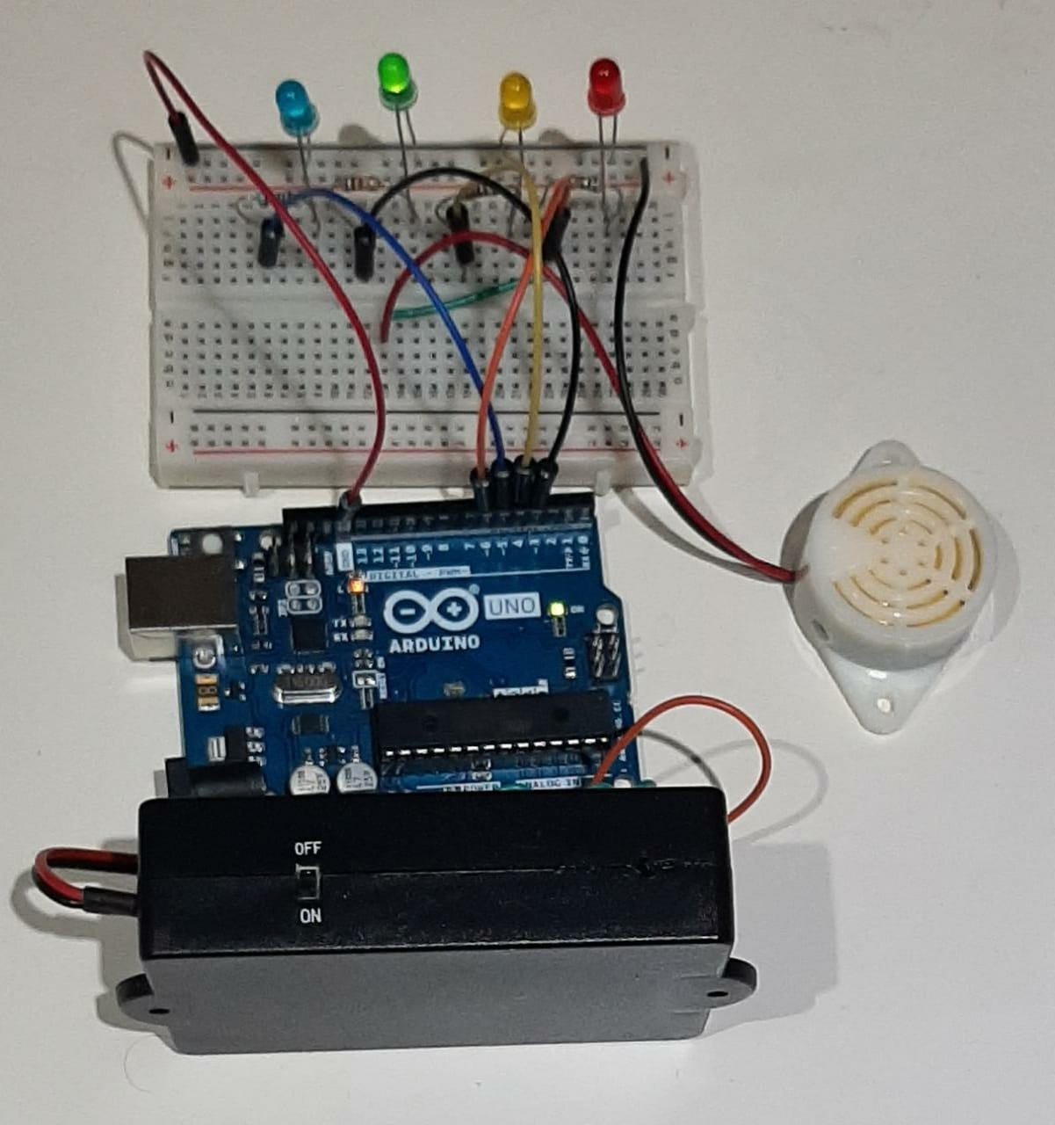

Figure 18 Implemented circuit Connection of Battery monitoring system

The above implemented circuit is also implemented (Tinkercad, n.d.) in Tinkercad, the downloaded image from the Tinkercad (Tinkercad, n.d.) is shown in below figure-19 also executed satisfactorily but in this the battery considered of 5V instead of 9V and programmed accordingly.

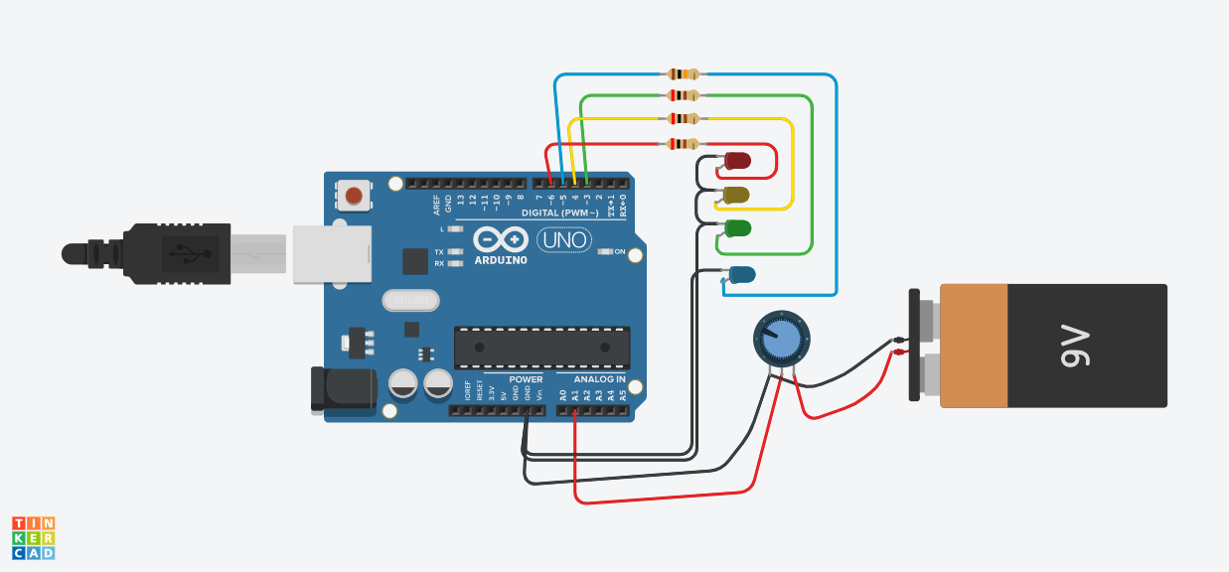

Figure 19 Implemented battery monitoring system in Tinkercad

### 5.1.3. CIRCUIT CONNECTION OF EV NAVIGATION SYSTEM TO LOCATE THE NEAREST CS BASED ON THE ALERTS FROM BATTERY MONITOING SYSTEM

In this project EV navigation system continuously finds the coordinates of the vehicle and readily available for the navigation to the desired location and can be track the vehicle on remote location which provides as security feature. This is also agentless but requires connection with WIFI connection to access the webpage to locate the coordinates in the maps. The GPS module sends the location coordinates to the local server and by login to the webpage to any device such as smart phone or computer to the webpage which give the access to locate in the position of the vehicle in Google Maps through a provided link from that webpage.

the circuit connection of EV navigation system is basic connection between the GPS module, ESP-01S with microcontroller, the Arduino uno given WIFI connection to access the cloud server and update the GPS data. This Arduino of the prototype get the supply from the car battery and the voltage levels should be checked before connecting to avoid damaged. The block diagram-3 is the illustration the connection of the GPS module, ESP01 with Arduino Uno microcontroller board and detail description of the connections is of each module is explained is done at below coming sections.

SATELLITE

Arduino Uno

ESP-01S

GPS MODULE

USER DEVICE

POWER SUPPLY

Block Diagram 3 block diagram showing connection of components to Arduino uno

**WIRING OF ESP-01S MODULE:**

ESP-01S module with respect to the Battery monitoring system outputs it is connected to GPS module and give access like WIFI shield and connects to the drivers monitoring devices wirelessly to locate the EV charging station and navigate through it. ESP-01 is a self-contained SOC, so it doesn’t alter with the working procedure of the connected circuit. ESP8266 is a low cost WIFI module with 1M memory.

Pin description and connections of the ESP-01 to Arduino Uno is described in following table-4.

Table 4 Pin description of ESP-01

|  |  |  |
| --- | --- | --- |
| **PIN** | **Arduino Pin** | **Description** |
| GND | GND | Ground terminal |
| GIPO2 | NOT CONNTECTED | General purpose digital input output pin |
| GIPO0 | NOT CONNECTED | General purpose digital input output pin, used for BOOT modes |
| RX | PIN D2 | Receiving channel |
| TX | PIN D3 | Transmitting channel |
| CH_PD | 3.3V | Enable pin |
| REST | NOT CONNECTED | Rest pin can connection pulled from 3.3V |
| VCC | 3.3V | Power supply |

This module operates at 3.3V and has to be connect with the resistor in series as extra protection if operating at 5V.

The ESP-01 module is set to operate at both AP and STA mode, which allows any device to connect with the Access point (AP) and get communicate with the microcontroller with this module.

**WIRING OF GPS MODULE**

To power the module, it is connection is done to VCC and ground through the Arduino pins and the transmitting, receiving pins connection can be done by connection to the serial communication pins of Arduino. As per (Anon, n.d.) The pin connections between Arduino uno and GPS module is listed below Table-5.

Table 5 Pin description of GPS module

|  |  |
| --- | --- |
| GPS | Arduino Uno |
| VCC | 5V |
| Rx | 11 |
| Tx | 10 |
| Ground | GND |

### 5.1.3. IMPLEMENTED CIRCUIT CONNECTION

In this project report the implemented circuit design for wireless EV navigation system used is in Figure-20.

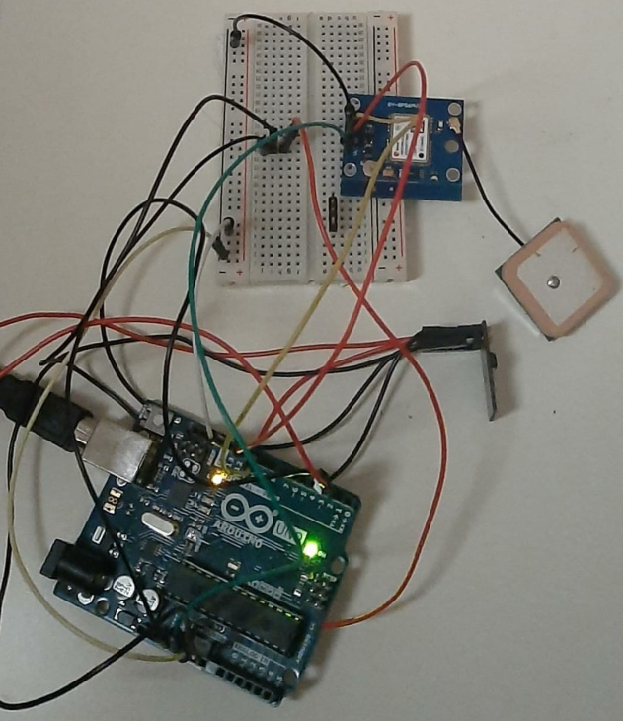



Figure 20 Implemented Circuit for EV Navigation



## 5.2. SOFTWARE IMPLEMENTATION

In this report for the software implementation the coding is done for the monitoring the status of the battery by considering the factors like capacity of battery, discharging current, voltage level of the battery and according to the workflow process described and agentless navigating system of the vehicle The code explanation of each component used for the system working is illustrated in this section.

### 5.2.1. BATTERY MONITORING ALGORITHM

The method of approach to program the code is to measure the capacity of the battery. The battery used here is lithium polymer (LiPo) of nominal voltage 3.7V which is under the suitable range of reference voltage of Arduino 5V, so this device doesn’t require voltage divider circuit.

The Arduino microcontroller sense the voltage on analog pin A1 and converts into digital format by the in-built feature of 10-bit ADC as referred from (Team, 2020).

The maximum resolution reading of the Arduino voltage is 5V/1024units =0.00488V or 4.9mV per unit resolution.

For the given input battery voltage, the Arduino reads the digital value of the voltage and voltage is calculated as per the following

Value = analog read (A1)

Vout = (value*5)/1024 V.

The rated capacity of the battery = 1800mAh

So, the 1800mAh capacity of battery can be said as 1.8A can be discharge in 1 hour, capacity of the battery is the power of the battery which a battery can hold (Electrical Technology, 2013).

In terms of Watt hour, the rated capacity of the battery is = 6.667Wh

The energy stored in the battery can be calculated as

Eb = Cb x V (Wh)

= 1.8 X V Wh

But, Cb = Id x T (Ah)

1.8 = Id X T

So, I = Cb x rate of discharge

= 1.8 x 1.5

= 2.7 A

Where,

Id = discharging current

Cb = battery capacity (Ah)

= Id x T (Ah)

= Eb/V

T = discharge rate of current

= 1.5C (h)

Eb = energy stored in battery

= Cb x V (Wh)

The max life of the battery = rated capacity of the battery / max load current (h)

= 1.8/2.7

=0.667 hours

= 40 minutes

Life of the battery is the time take for the battery to discharge or charge

When 20% of the efficiency loss are considered then

Capacity of the battery = 1.8 x 20%

= 2.16 Ah

Time taken to charge at 20% of the efficiency loss

= 2.16/load current

= 2.16/ 2.7

= 0.8 h

= 48 mins

The maximum time taken by the battery to charge is 0.667h where no efficiency loss is considered.

for 20% efficiency loss the time taken to charge the battery is 0.8h

Where,

h = hours

Wh = Watt-hours

Ah = Ampere- hours

V = volts

A = Ampere

Thus, by using above all expressions the discharging current, capacity of battery and voltage level of the battery can be calculated. And approach to this system can described in below flowchart. Based on this flowchart the code the proposed system.

Flowchart 2 Procedure to Program the Battery Monitoring System

Arduino reads the battery voltage level in discrete form

Calculate battery capacity, voltage level, discharging current

Check voltage level

Blink blue LED as indication of the battery is being overcharged

Is V>3.7?

No

Blink Green LED as the indication of battery is being the nominal charge capacity

No

Is V<=3.7&&V>3?

Blink Red LED with buzzer as the indication of reaching the cut-off voltage of the battery and recharge the battery immediately

Yes

Is V<2.7

No

Blink Yellow LED as the dedication battery discharged %50 and locate to the CS

In this code, we have used SerialSoftware library to interface battery with the Arduino as shown in Figure-21 a part of code implemented is displayed.

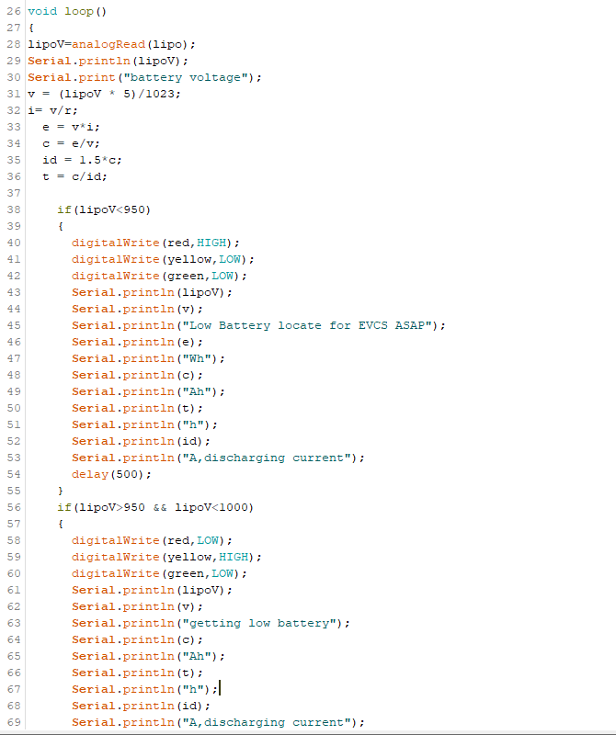

Figure 21 Showing Part of Arduino IDE code for Battery monitoring system

### 5.2.2. INTEGRATING THE WIFI MODULE AND GPS MODULE

First step is to configure the WIFI module to router to use it as local server to send GPS data to web browser. This process of configuration can be done by sending the AT commands and after each execution of the AT commands it revert backs with “OK” response. The list of AT commands used in developing the code by referring from (ESP8266 AT Instruction Set, n.d.), (Circuitdigest.com, 2016) is explained below tabular column Table-6.

Table 6 AT commands of WIFI module

|  |  |
| --- | --- |
| **COMMANDS** | **DESCRIPTION** |
| AT | Start-up connection |
| AT+CWMODE=mode-id | Selection of the mode as described above with 1or2or3 |
| AT+CWQAP | This command sets the module in default auto connected to previously available Wi-Fi network |
| AT_RST | Restarts the module |
| AT+CWJAP=” wifi_username”,” wifi_password” | This command connects to specified SSID of an AP |
| AT+CIFSR | Displays the obtained IP address |
| AT+CIPMUX=1 | This command used to enable or disable the connections by 1,0 respectively. |
| AT+CIPSERVER=1, port_no | Creates/deletes a TCP server with 1,0 respectively |
| AT+CIPSEND=id, length of data | Sends data with id and data length of max 2KB |
| AT+CIPCLOSE=0 | Closes the established connections |

Steps of code involved in programming.

* + - 1. Initialize serial communication with defined library like SoftwareSerial and declare the variable, strings to the pin connections made.
      2. Initialize the serial communication such as Serial1.begin(9600); Serial. Begin (9600), gps.begin(9600); and by sending required AT commands to establish the Wi-Fi connection.
      3. Allocation of required functions to gather the GPS data with coordinates such as shown in below screenshots of the Arduino code implemented in this report. The GPS data that is received from the satellite is in the form of degree. Minute format (ddmm. mmmm), which is required to convert format of the decimal degree used in search location of Google Maps by only converting the minute part in decimal and can be done by dividing the minute by 60.
      4. The read function command is set to read the data from the Wi-Fi module and send the data to webpage or to the server of module. The webpage data can be read by login into IP address of the local server.

# Chapter 6: EXPERIMENTAL RESULT

This chapter of this project deals with the testing of implemented prototype at different level to ensure the output from the system produce is expected and meets the objectives of the project to greater extent. In this section the represents the outcomes of battery monitoring system and navigating system separately to check the performance before integrating with both systems described in this report.

## 6.1. BATTERY MONITORING SYSTEM

Here the battery is completely discharged to its cut-ff voltage level and charged from low battery level to ensure the satisfactory working of the battery at different phases to know the charge capacity of the battery. Figure-22 shows the working of the battery at different levels such as at following phases.

* Low battery phase: In this phase the battery capacity condition is indicated by red led, when the red led glows showing that the voltage level of the battery is discharging to its cut-off value of the battery and soon going to discharge completely and at this phase the buzzer also alarms the driver of EV to conserve the battery and charge battery immediately at nearest possible charging station.

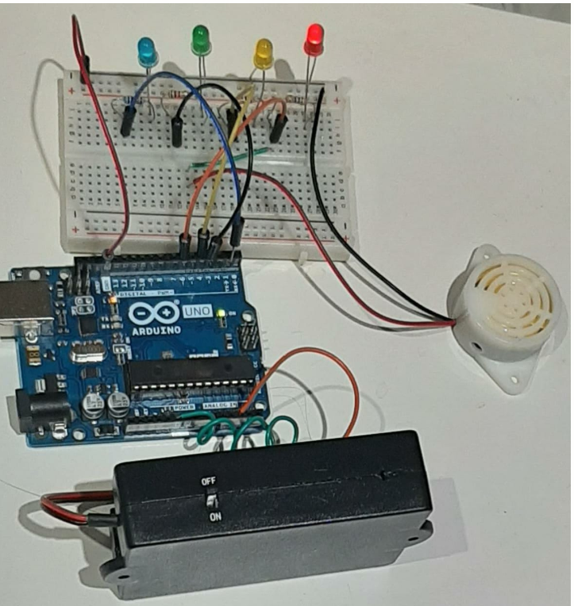

Figure 22 Battery at Low Phase Indicating with Red LED

* Getting low battery phase: In this phase the battery consumes the half of capacity of the battery and alerts the driver about the capacity condition of the battery to the driver the yellow led as indicator. In this state of phase, the driver must try locating the EV charging station and gives time to driver to plan the trip accordingly. As shown in below Figure-23 the battery the yellow led light glows and this stage the EV driver must open the EV navigation system which shows the current position to the driver based on the GPS data on to the google maps to locate the CS from his location.

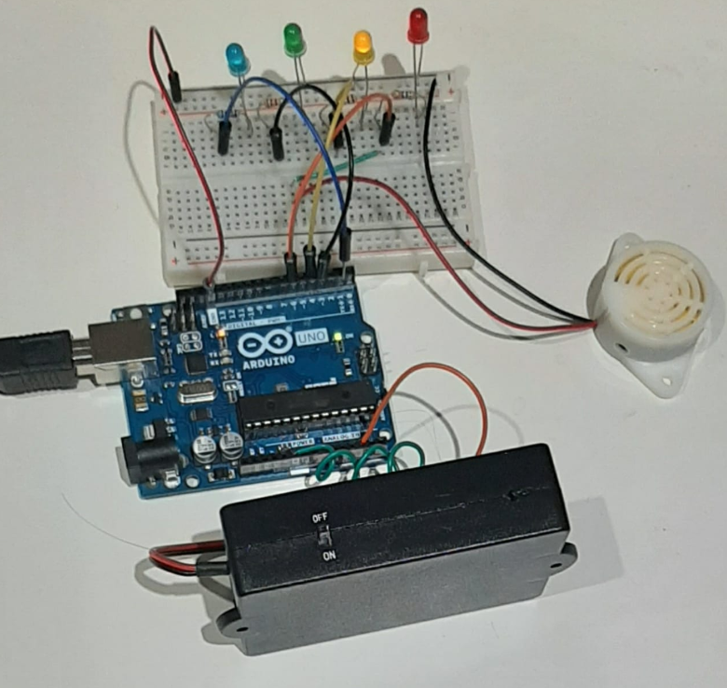

Figure 23 Half Discharge Phase of Battery Indicating with Yellow LED

* Green charged phase: In this phase the battery capacity and voltage level or the charge status is in the safe limit can be known by the green led as indicator as per Figure-24. This ensure the battery is in the safe charge status level. Here driver can plan the trip without be in hassle to range anxiety till it changes to next yellow led indicator.



Figure 24 Safe charged Phase of Battery Indicating with Green LED

* Battery overcharging alert phase: In this phase the blue led glows to alert the driver to avoid the overcharging the battery. Figure-25 shows the developed circuit operating at the overcharging phase with blue led high state.

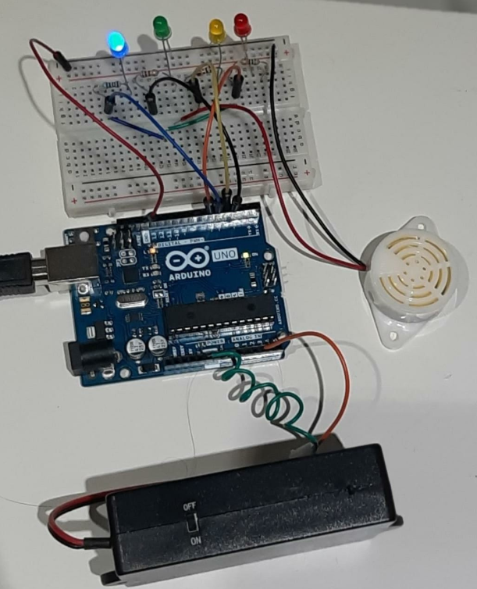

Figure 25 Overcharging Alert Phase of Battery indicating with Blue LED

Figure-26 shows the output results obtained in the serial monitor, here the battery at low charge state the other parameters such as battery capacity, energy, discharging current can be noticed.

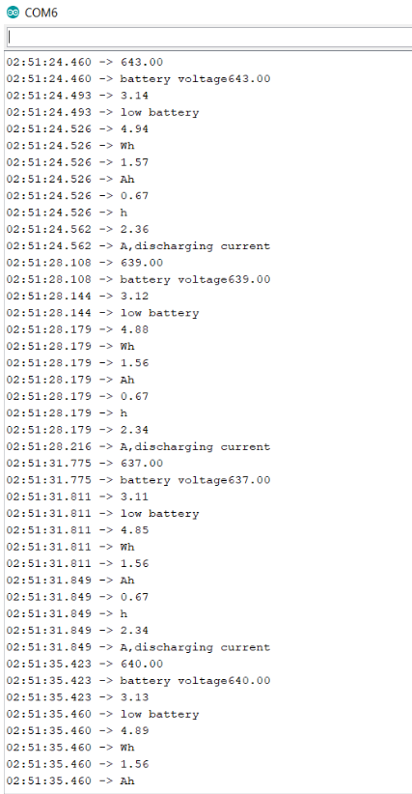

Figure 26 Serial Monitor Data of Battery Monitoring system

## 6.2. EV NAVIGATION SYSTEM:

As this system is executed separately without combining the battery monitoring system but this system is developed to integrate with the battery monitoring system to get the data of battery parameters to driver so the driver can automatically can get the alerts in their devices in one platform. But in this report to check the output of the develop system performance it is executed separately.

This system always monitors the geolocation of the vehicle as GPS in this gets the data from the satellite so it performs fast with exact position and the location of the vehicle can be monitored at any time in the maps with the ESP8266 which creates IP its local server. Below Figure-27 and Figure-28 shows the communication between Wi-Fi module and Arduino on the Serial Monitor as connected WIFI with IP address and by refreshing the page it updates the location of vehicle.

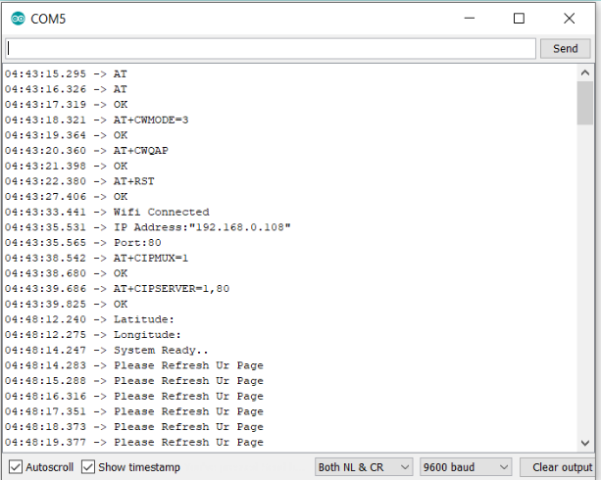

Figure 27 Serial Monitor Data Showing the Established WIFI and GPS connection

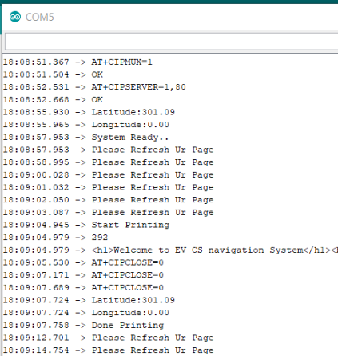

Figure 28 Serial Monitor Data Showing the Access of Data Through Webpage

Figure-29 shows the login page of the local server when searched with the IP address of the server.

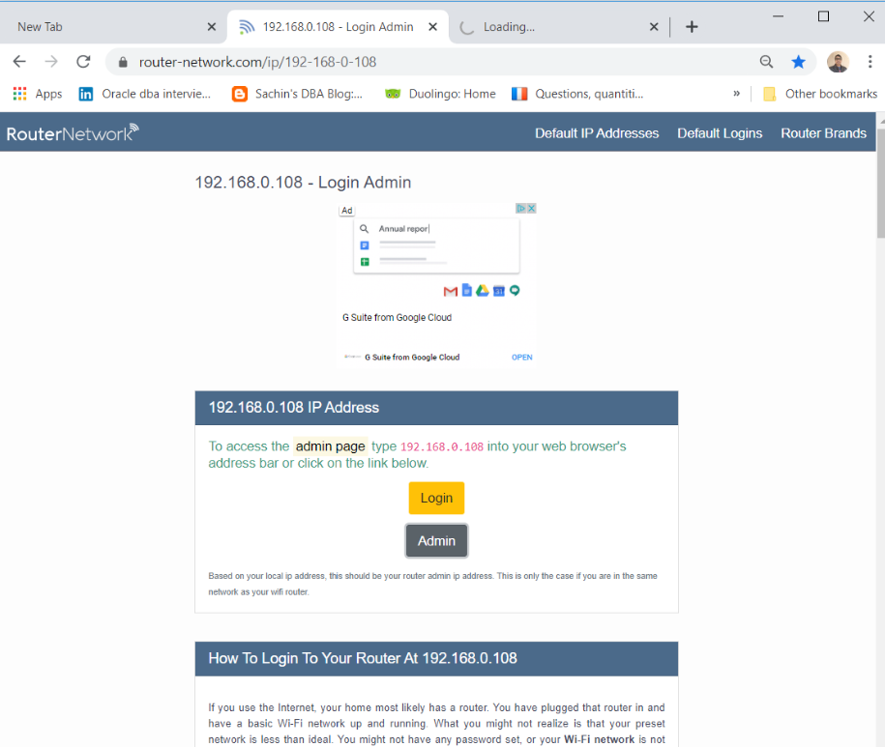

Figure 29 Login Page of Local Server through IP address

After login into page it is redirected to the webpage of the EV navigation system with the details of the required details of the vehicle like vehicle number, name of the EV driver location of vehicle with coordinate. Figure-30 shows the webpage with information executed in this report.

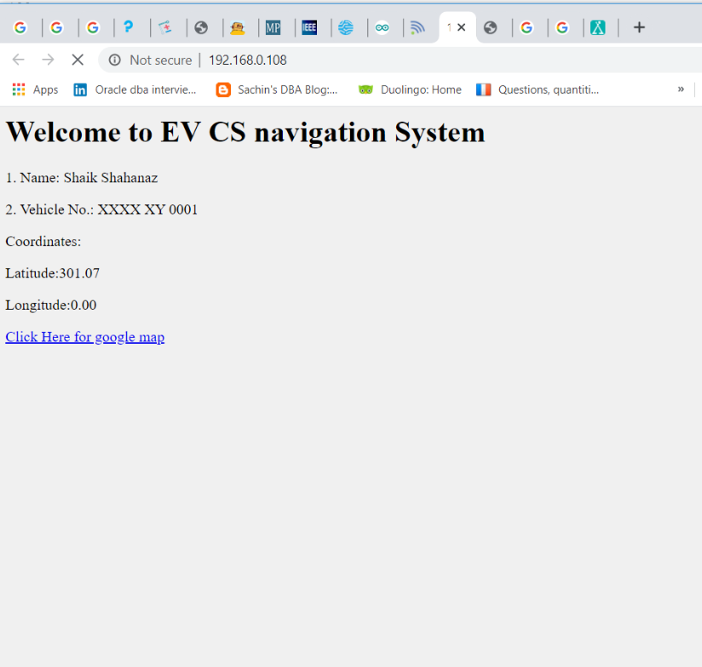

Figure 30 Webpage showing the coordinates of the EV

## 6.3. DISSCUSSIONS

This proposed system can be useful to all the EV drivers and other battery equipped vehicles. The are many advantages of employing this proposed system in the project such as reduction of the range anxiety of EV driver as the driver can know the battery capacity and based on this driver can alter the power consumption and plan the trip by locating the CS accordingly, can able to monitor the battery status, maintains the health of battery by provided alert system of being overcharged and at low battery conditions, can able to locate the position of the vehicle anywhere which provides the security to vehicle. Though it many advantages there are certain limitations to the proposed such as it requires systematic approach of development of set of procedures required to establish the communication of each CS to driver, the data from GPS module can be accesses through the WIFI connection as discussed from this report and this can be suitable for the EV with WIFI connection, but this can be overcome integrating the GSM module with GPS module.

In this report two system is developed differently can be combine to single microcontroller and programmed accordingly. Due to time constraints and availability of resources, this system is not able to develop as meant to be to produce the output by using single microcontroller.

# Chapter 7: CONCLUSION, FUTURE WORK AND LIMITATIONS

In this research project, the proposed system provides the agentless charging recommendation to EV based on the charge status of the battery and navigate through the nearest suitable charging station in Google Maps from location of the vehicle provided by the GPS data. This research project tries to provide the solution overcome the problem faced by the driver of EV based on the charging the vehicle and planning the trip. The report mainly focuses on the simplification approach for CS at low battery juice level. This report project tries to implement an automatic real- time system where driver can easily locate the place to charge the vehicle on the move, to reduce the wait time near the charging slots, can be able to plan the trip in advance, can able to detect the suitable CS from the vehicle in terms to time , distance and traffic congestion from google maps. concept presented in this report is considered as basic step for further discussions and developments.

The proposed work in this report are having several concerns which leads to further future works to improve and more features such as

1. To add GSM shield with GPS to the navigation system to send data to the web server as sometimes the internet WIFI facilitates may not work properly.
2. To enhance the Battery monitoring system to send its data wirelessly to the user’s accessibility devices so that the EV driver can monitor all the parameters from one platform.
3. Further research studies to carried out for the implementation of efficient communication system between the CS and EV driver to fulfill the supply demand gap and EV driver can optimize the selection of CS based on the service facilities details provided by CS.
4. The test results must be carried out in varied parameter at different working conditions by using simulators to test and to collect the subsequent amount of the data collection.

The limitations arise while working on this research project were:

Time: For the development of the Qualitative project it requires much more research studies. The period of research work majorly affects by the Covid restrictions as some of the component’s costs were too high and ordered components are delayed in delivery, so it takes limited time to program.

Quality Results: the amount of time to spent on testing the developed prototype on different factors of environment couldn’t carrier out due to limited time. So, this research project subjected to limited number of test and data collections.

# ACKNOWLEDGEMENTS

I am extremely grateful to Almighty God, who gave me the opportunity and ability to complete this work.

My sincere acknowledgement goes to NTU university and supervisor Professor Omprakash Kaiwartya, who has trusted me and given opportunity to work with him. Under his inspiration and endless support throughout the period of my study I has gained knowledge and through his continuous feedback and suggestions helps me to understand and finish my work.

I am also thankful to my family members, who always support me during my period of study. Finally, I am indebted and thankful to my children, Sara and Aryan for their patience and support to continue my studies with ease.

# REFERENCES

New.engineering.com. 2020. Make: Projects. [online] Available at: <https://new.engineering.com/story/what-you-need-to-know-about-batteries-for-electric-vehicles> [Accessed 4 September 2020].

Anon, (n.d.). How to interface a GPS module with Arduino – idyl.io. [online] Available at: https://idyl.io/arduino/how-to/interface-gps-module-arduino/ [Accessed 4 Sep. 2020].

‌EV Connect. (n.d.). EV Connect Network | Manage Your EV Charging Stations. [online] Available at: https://www.evconnect.com/charging-solutions/ [Accessed 4 Sep. 2020].

Osoyoo.com. (2018). Arduino lesson – Voltage Sensor Module « osoyoo.com. [online] Available at: https://osoyoo.com/2018/11/06/arduino-lesson-voltage-sensor-module/ [Accessed 4 Sep. 2020].

‌ learn.sparkfun.com. (n.d.). Analog to Digital Conversion - learn.sparkfun.com. [online] Available at: https://learn.sparkfun.com/tutorials/analog-to-digital-conversion [Accessed 4 Sep. 2020].

‌ Tinkercad. (n.d.). Tinkercad | From mind to design in minutes. [online] Available at: https://www.tinkercad.com/things/knStfcKtAi4-editing-components/editel?lessonid=EFU6PEHIXGFUR1J&projectid=OIYJ88OJ3OPN3EA#/lesson-viewer [Accessed 4 Sep. 2020].

‌ ElectroSchematics.com. (2013). Digital Arduino Voltmeter 0V-12V-30V. [online] Available at: https://www.electroschematics.com/arduino-digital-voltmeter/.

‌ Team, D.E. (2020). The Basics of Arduino: Reading Voltage. [online] Device Plus. Available at: https://www.deviceplus.com/arduino/the-basics-of-arduino-reading-voltage/ [Accessed 4 Sep. 2020].

‌ Staff (2010). Designing battery management systems for electric vehicles. [online] Electronics Weekly. Available at: https://www.electronicsweekly.com/market-sectors/automotive-electronics/designing-battery-management-systems-for-electric-vehicles-2010-02/ [Accessed 4 Sep. 2020].

‌ EVreporter. (n.d.). Why is a Battery Management System needed in Electric Vehicles? • EVreporter. [online] Available at: https://evreporter.com/battery-management-system-for-electric-vehicles/ [Accessed 4 Sep. 2020].

‌ Madaan, S. (2016). 5 Primary Causes of Air Pollution. [online] Earth Eclipse. Available at: https://www.eartheclipse.com/pollution/primary-causes-of-air-pollution.html.

‌ Cao, Y., Wang, T., Kaiwartya, O., Min, G., Ahmad, N. and Abdullah, A.H. (2018). An EV Charging Management System Concerning Drivers’ Trip Duration and Mobility Uncertainty. IEEE Transactions on Systems, Man, and Cybernetics: Systems, [online] 48(4), pp.596–607. Available at: https://ieeexplore.ieee.org/document/7756376 [Accessed 4 Sep. 2020].

‌ Menghua, W. and Bing, X. (2017). A Real-Time Android-Based Monitoring System for the Power Lithium-Ion Battery Used on EVs. [online] IEEE Xplore. Available at: https://ieeexplore.ieee.org/document/8089945 [Accessed 4 Sep. 2020].

Driivz. (n.d.). EV Charging Solutions for Electric Vehicle Service Providers. [online] Available at: https://driivz.com/solutions/electric-vehicle-service-provider/ [Accessed 4 Sep. 2020].

Ferreira, J., Pereira, P. and Filipe, P. (n.d.). Recommender System for Drivers of Electric Vehicles. [online] Available at: https://core.ac.uk/download/pdf/55619863.pdf [Accessed 22 May 2020].

‌ Cao, Y., Kaiwartya, O., Zhuang, Y., Ahmad, N., Sun, Y. and Lloret, J. (2019). A Decentralized Deadline-Driven Electric Vehicle Charging Recommendation. IEEE Systems Journal, 13(3), pp.3410–3421.

‌ Marmaras, C., Xydas, E. and Cipcigan, L. (2017). Simulation of electric vehicle driver behaviour in road transport and electric power networks. Transportation Research Part C: Emerging Technologies, [online] 80, pp.239–256. Available at: https://www.sciencedirect.com/science/article/pii/S0968090X17301341.

‌ Cao, Y., Yang, S., Min, G., Zhang, X., Song, H., Kaiwartya, O. and Aslam, N. (2017). A Cost-Efficient Communication Framework for Battery-Switch-Based Electric Vehicle Charging. IEEE Communications Magazine, 55(5), pp.162–169.

‌ Cao, Y., Wang, T., Kaiwartya, O., Min, G., Ahmad, N. and Abdullah, A.H. (2018). An EV Charging Management System Concerning Drivers’ Trip Duration and Mobility Uncertainty. IEEE Transactions on Systems, Man, and Cybernetics: Systems, [online] 48(4), pp.596–607. Available at: https://ieeexplore.ieee.org/document/7756376.

‌Cao, Y., Song, H., Kaiwartya, O., Zhou, B., Zhuang, Y., Cao, Y. and Zhang, X. (2018). Mobile Edge Computing for Big-Data-Enabled Electric Vehicle Charging. IEEE Communications Magazine, 56(3), pp.150–156.

‌Cao, Y., Jiang, T., Kaiwartya, O., Sun, H., Zhou, H. and Wang, R. (2019). Toward Pre-Empted EV Charging Recommendation Through V2V-Based Reservation System. IEEE Transactions on Systems, Man, and Cybernetics: Systems, pp.1–14.

‌uk.nec.com. (n.d.). Electric Vehicle (EV) Charging Infrastructure: NEC’s Case Studies | NEC. [online] Available at: https://uk.nec.com/en_GB/global/solutions/energy/charge.html [Accessed 4 Sep. 2020].

‌ ESP8266 AT Instruction Set. (n.d.). [online] Available at: https://www.espressif.com/sites/default/files/documentation/4a-esp8266_at_instruction_set_en.pdf [Accessed 4 Sep. 2020].

vi.raptor.ebaydesc.com. (n.d.). eBay. [online] Available at: http://vi.raptor.ebaydesc.com/ws/eBayISAPI.dll?ViewItemDescV4&item=193542767746&category=4660&pm=1&ds=0&t=1596537216000&ver=0 [Accessed 4 Sep. 2020].

‌aliexpress.ru. (n.d.). 45.12руб. 14% СКИДКА|Электронный звуковой сигнал TZT 95 дБ с высоким децибел 3 24 в 12 В, непрерывный звуковой сигнал для Arduino, сигнал для Arduino, сигнал|Акустические компоненты| | АлиЭкспресс. [online] Available at: https://aliexpress.ru/item/32963308015.html?spm=a2g0v.12057483.0.0.13501dd8uR8kaq [Accessed 4 Sep. 2020].

‌Electrical Technology (2013). How to Calculate the Battery Charging Time & Battery Charging Current – Example. [online] ELECTRICAL TECHNOLOGY. Available at: https://www.electricaltechnology.org/2013/03/easy-charging-time-formula-for.html.

‌